Computational Physics HW 3 Outputs

Christine Pho

3/8/2019

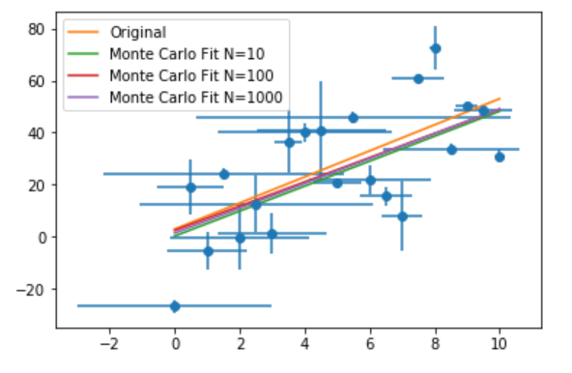

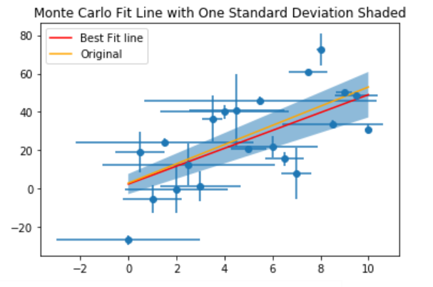

Discussion:

1. These results are similar to what I got in class with uniformly distributed error. However, since I used normally distributed error, there would occasionally be data points with outliers in the error. And therefore, there would be larger spread in each of the data points. So, the fitting may not be as accurate with the normally distributed error, simply because the data is noisier.
2. As the intrinsic scatter and error bars are increased, the fit becomes less accurate. It may be necessary to include two standard deviations above and below the fitted line in order for the original theoretical line to be included within the shaded region.